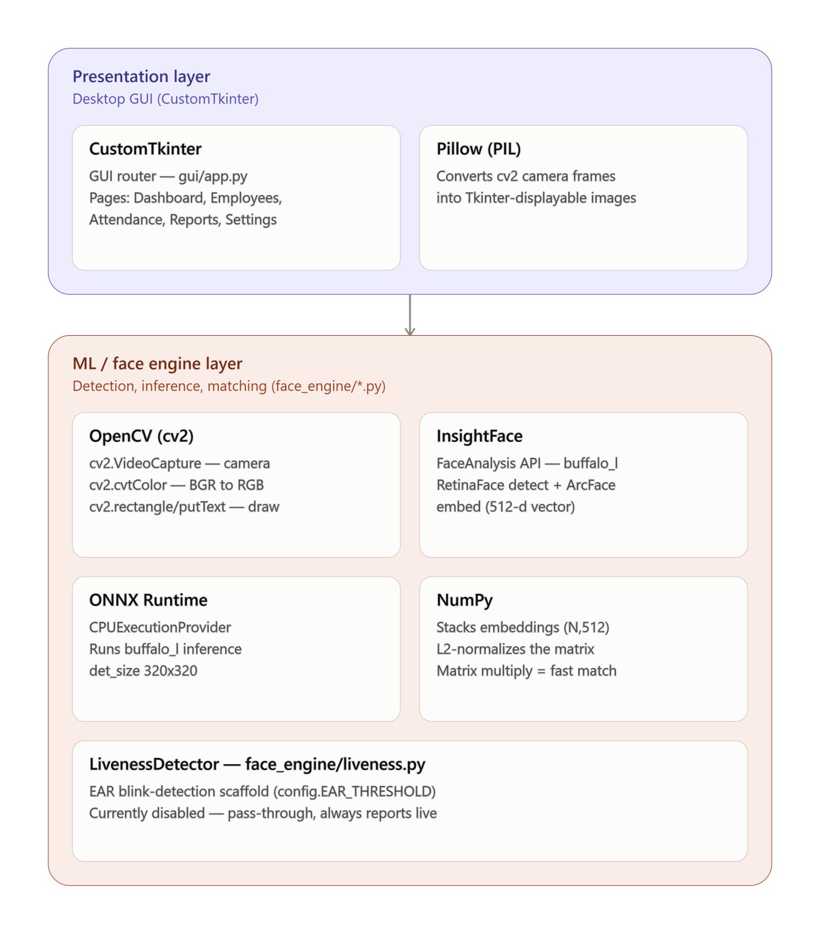

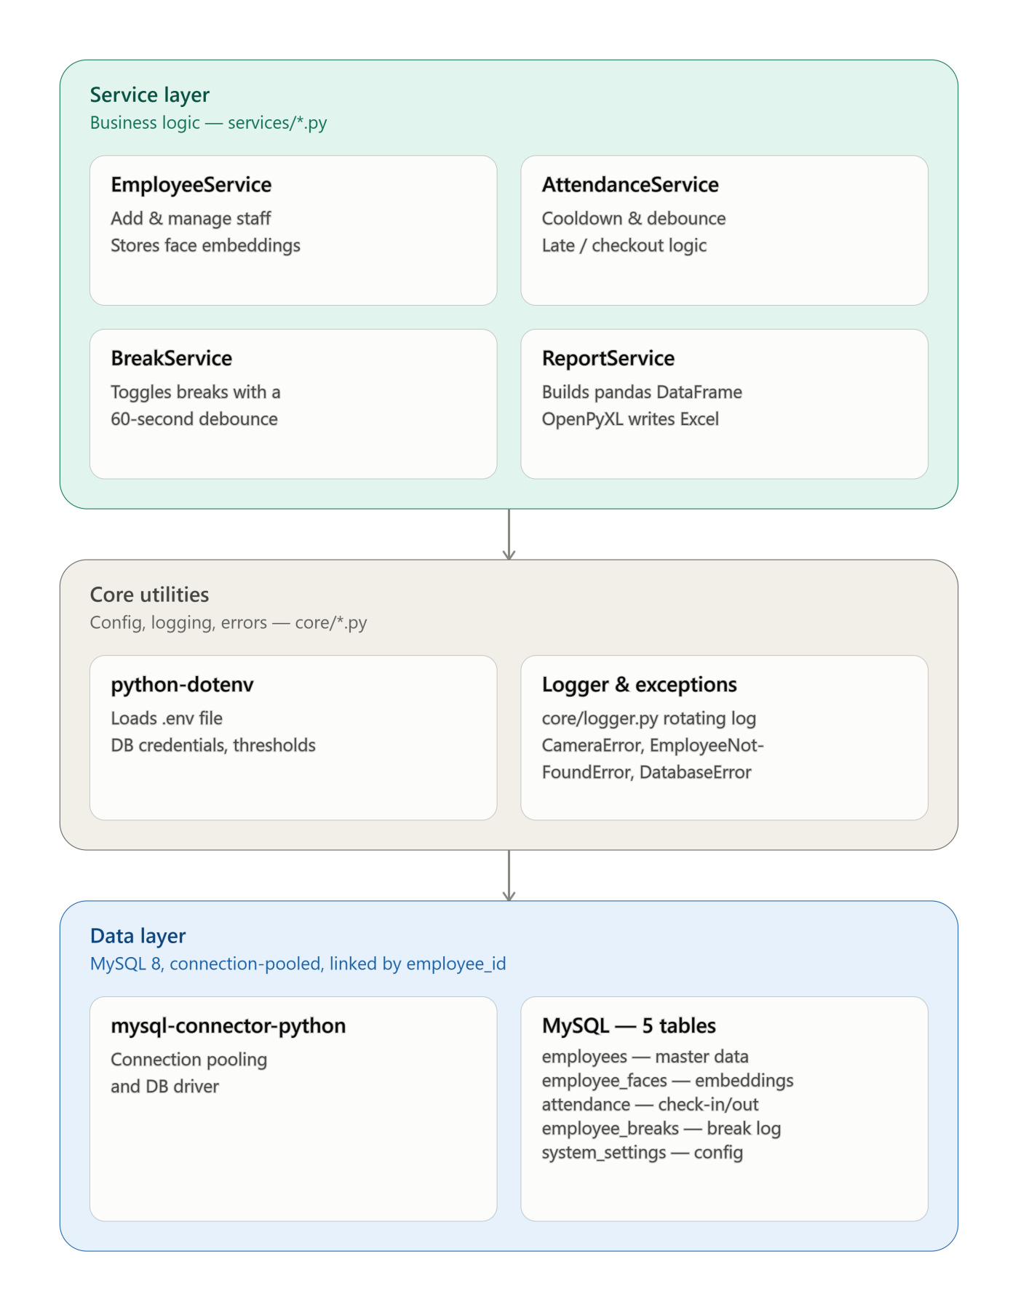

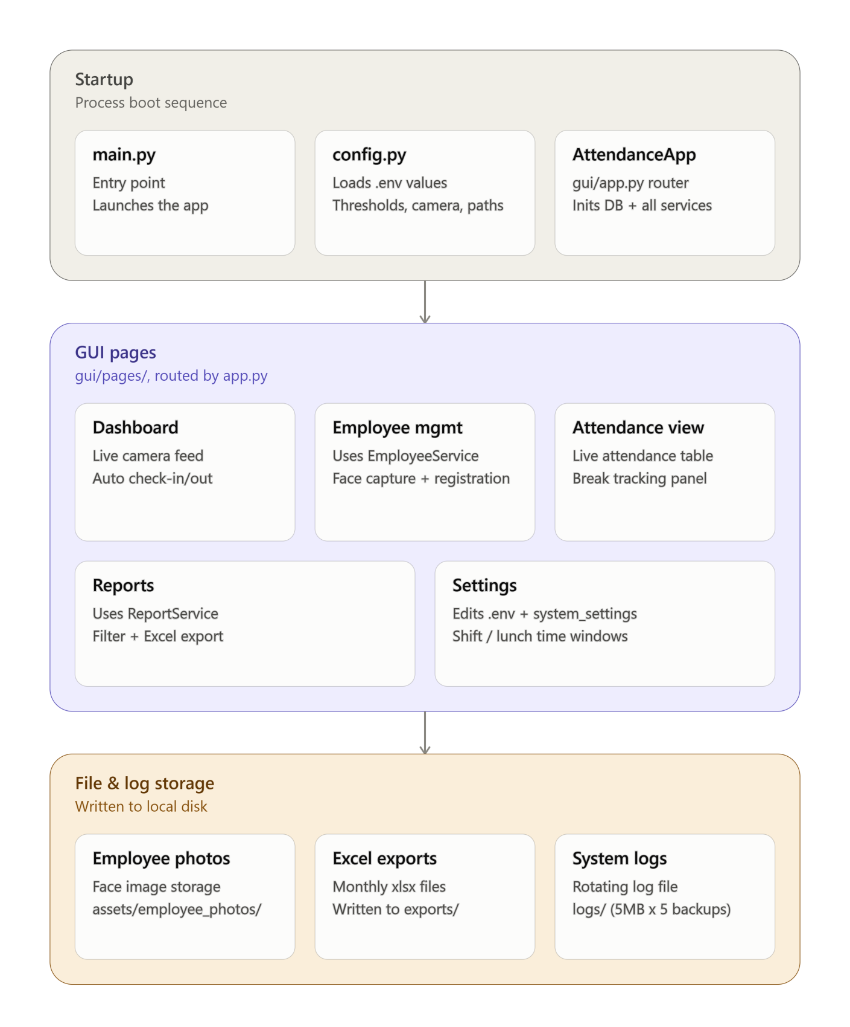

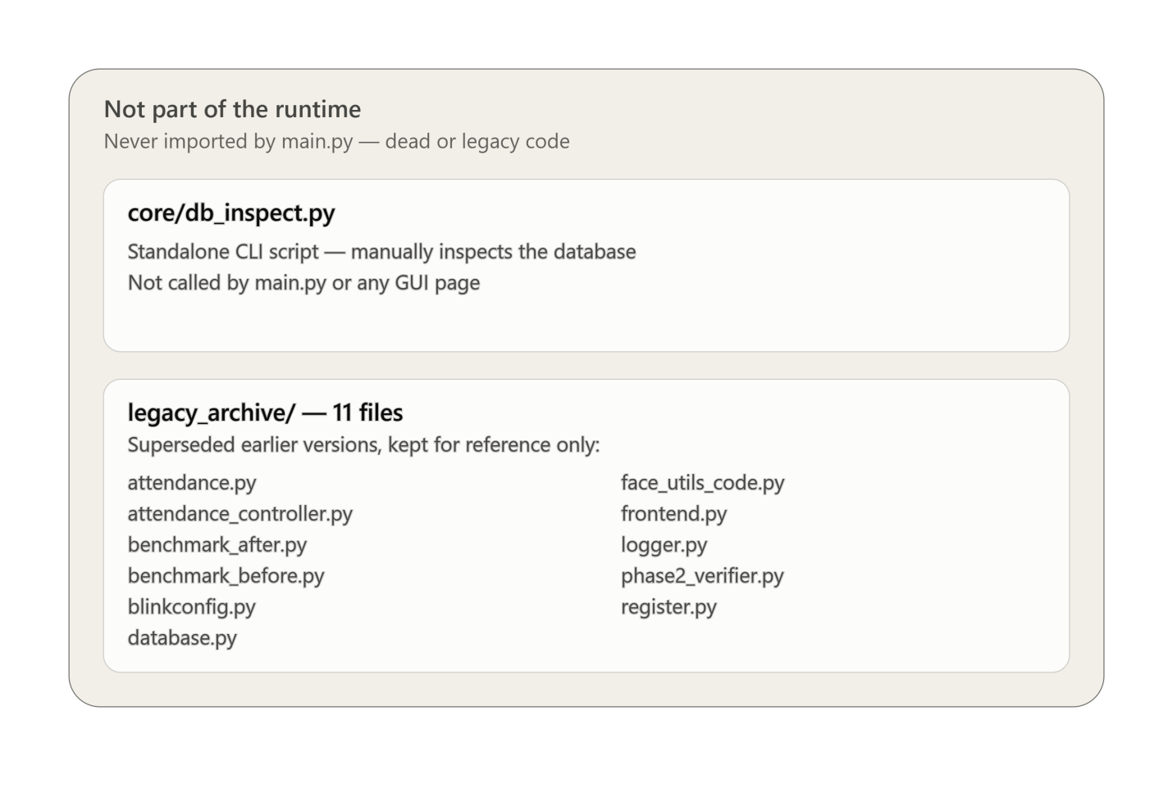

Archived file | Concept it holds | Where that concept lives now
attendance.py | Simple check-in cooldown via a {emp_id: last_mark_time} dict | services/attendance_service.py — same cooldown idea, now with per-employee threading.Lock, DB-backed debounce, and working-hours math
attendance_controller.py | One class wiring camera + recognizer + DB directly for the live loop | gui/pages/dashboard.py — the recognition_worker thread + update_frame loop, now going through the services layer instead of straight to the DB
benchmark_before.py | Timing of the original O(n) per-employee similarity loop | Documents the "before" state — the loop recognizer.py's vectorized matrix-multiply replaced
benchmark_after.py | Timing of the new vectorized NumPy matrix similarity | Confirms the 10×–50× speedup claim written in face_engine/recognizer.py's docstring
blinkconfig.py | EAR_THRESHOLD = 0.21, CONSECUTIVE_FRAMES = 3 | config.py — same two values; the code explicitly comments "absorbed from blinkconfig.py"
database.py | Backward-compat shim — from database import Database still resolves | core/database.py — the real MySQLConnectionPool-backed Database class it re-exports
face_utils_code.py | Backward-compat shim — from face_utils_code import FaceRecognizer still resolves | face_engine/recognizer.py — the real vectorized FaceRecognizer it re-exports
frontend.py | Original one-button plain Tkinter window ("Start Camera") | gui/app.py + gui/pages/*.py — today's 5-page CustomTkinter app
logger.py | Empty file (0 bytes) | core/logger.py — the real rotating file + console logger
phase2_verifier.py | QA script checking threads, memory leaks, performance & correctness after the rewrite | One-time validation tool — no direct successor, it verified the current architecture is correct
register.py | Standalone script: its own DB connection + its own FaceAnalysis instance to enroll one employee from the command line | gui/pages/employee_mgmt.py's capture_process() — same enrollment idea, now built into the GUI

